**Aws Account Creation Steps**

Step1: Open chrome browser paste this URL for AWS cloud account creation

<https://aws.amazon.com/>

* You will be landed to the aws Log-in Page.

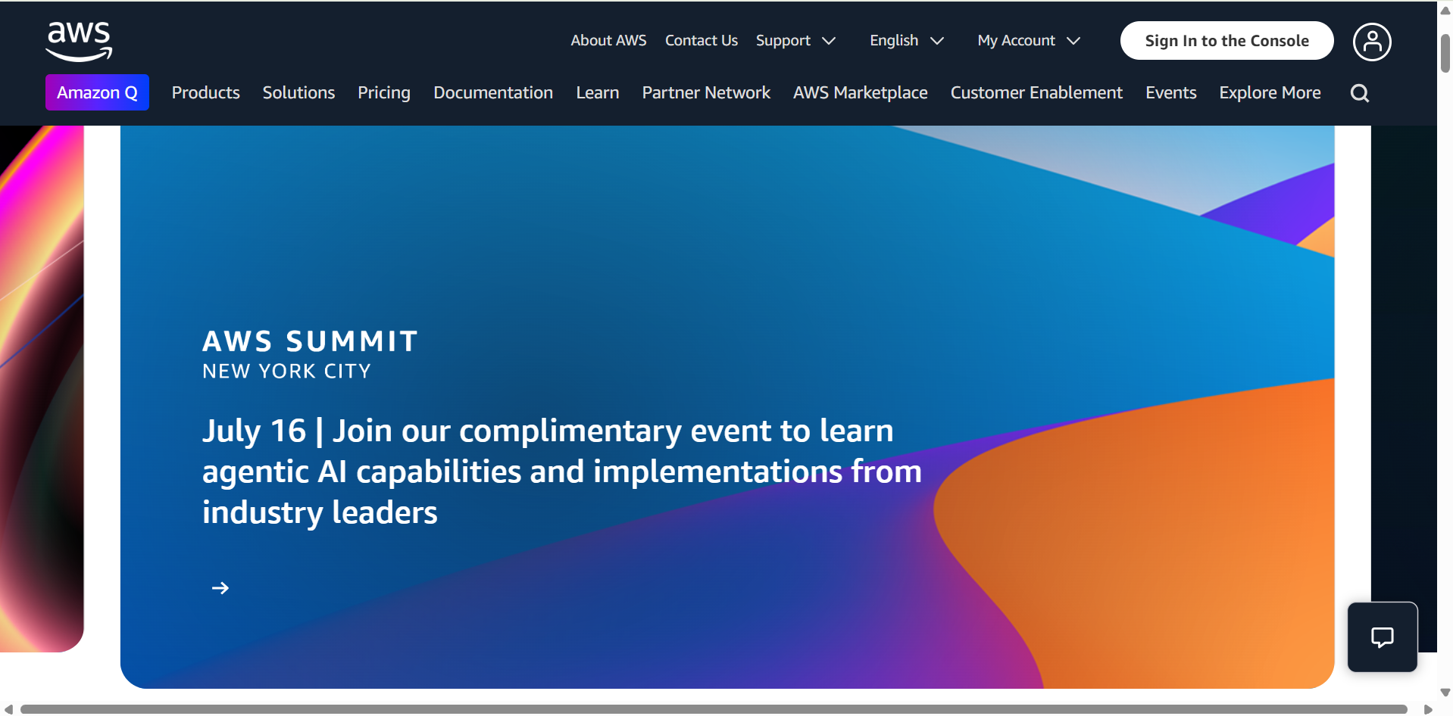

Step 2: Click on Sign in to the Console option

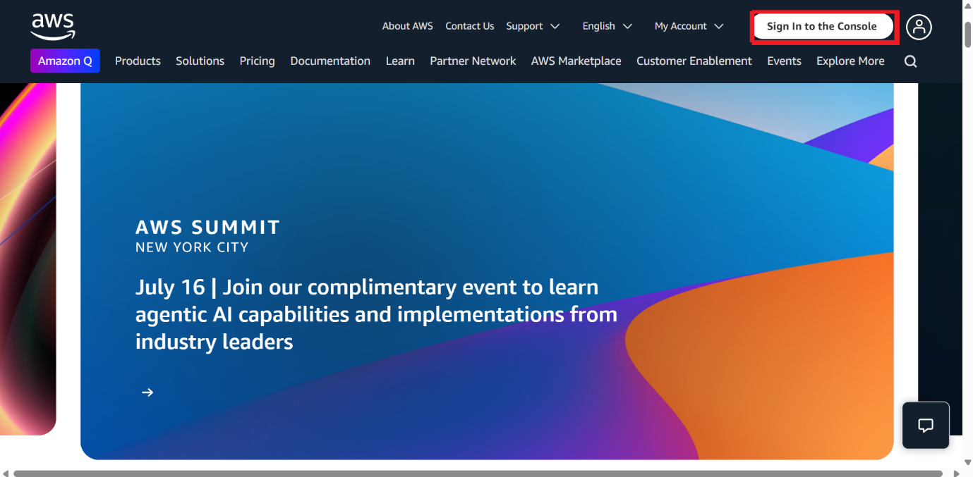

Step 3: Click on Create a new Aws account

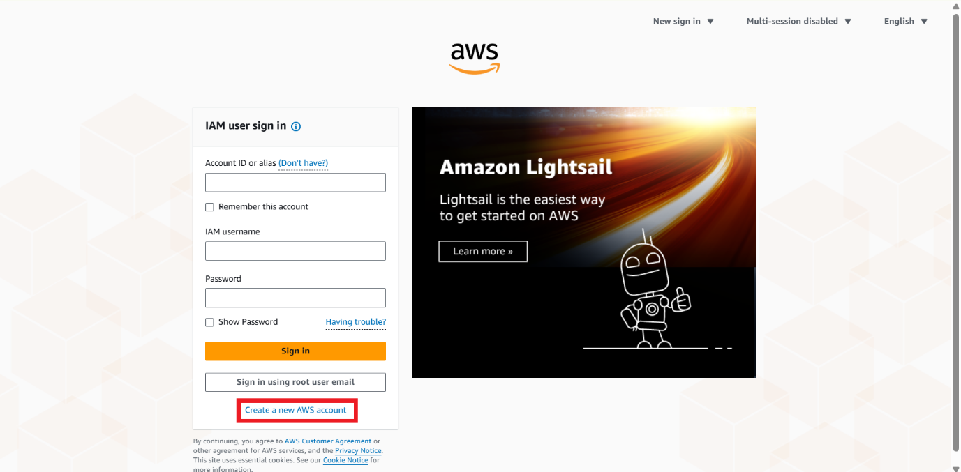

Step 4: . Enter EMAIL and ACCOUNT NAME (Any Name) then Click on Verify email address. For Entered Gmail you will receive Verification code.

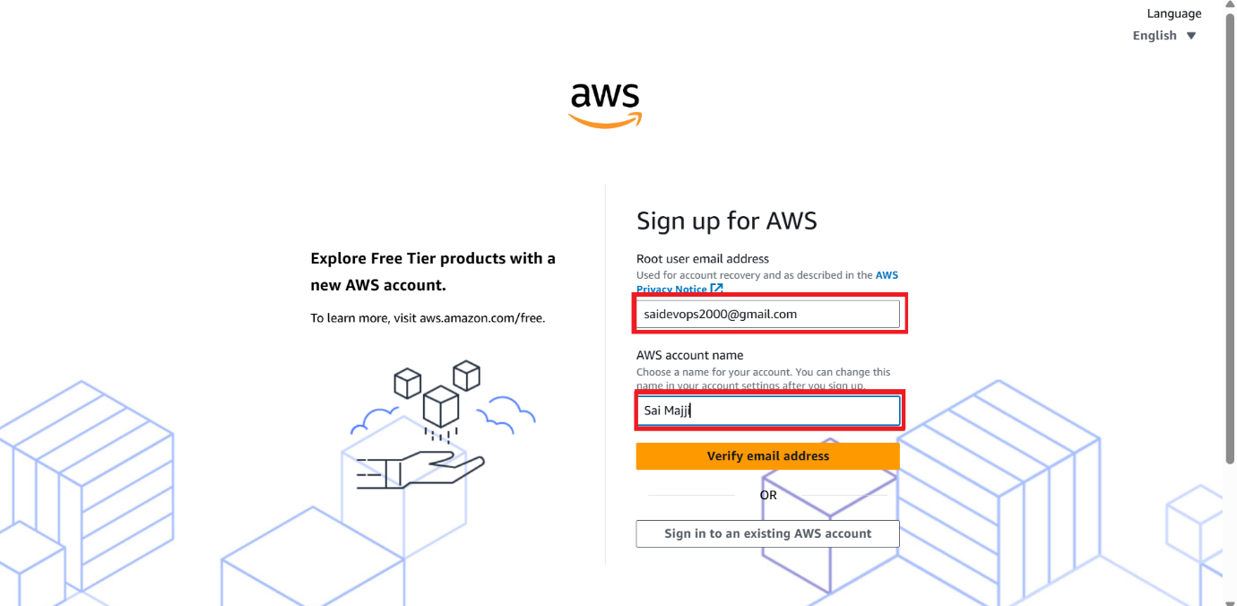



Step 5: Check Your Gmail for Verification code and Enter the code in the box. Then click on Verify option.

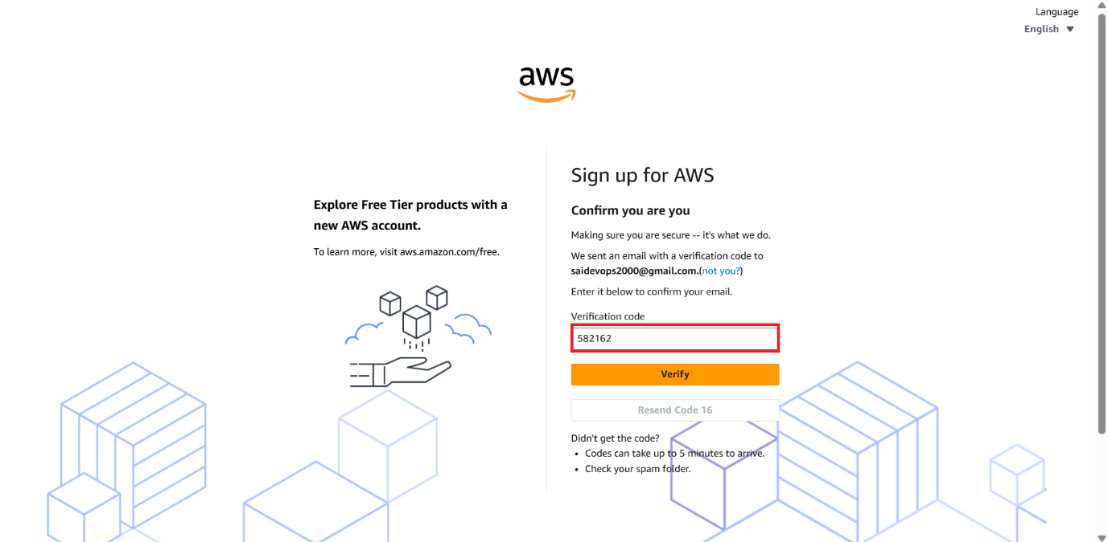

Step 6: You can see Gmail Verification Success Message and you need enter

Root User Password (For 2 times to confirmation) 🡪 **Step 1 completed out of 5**

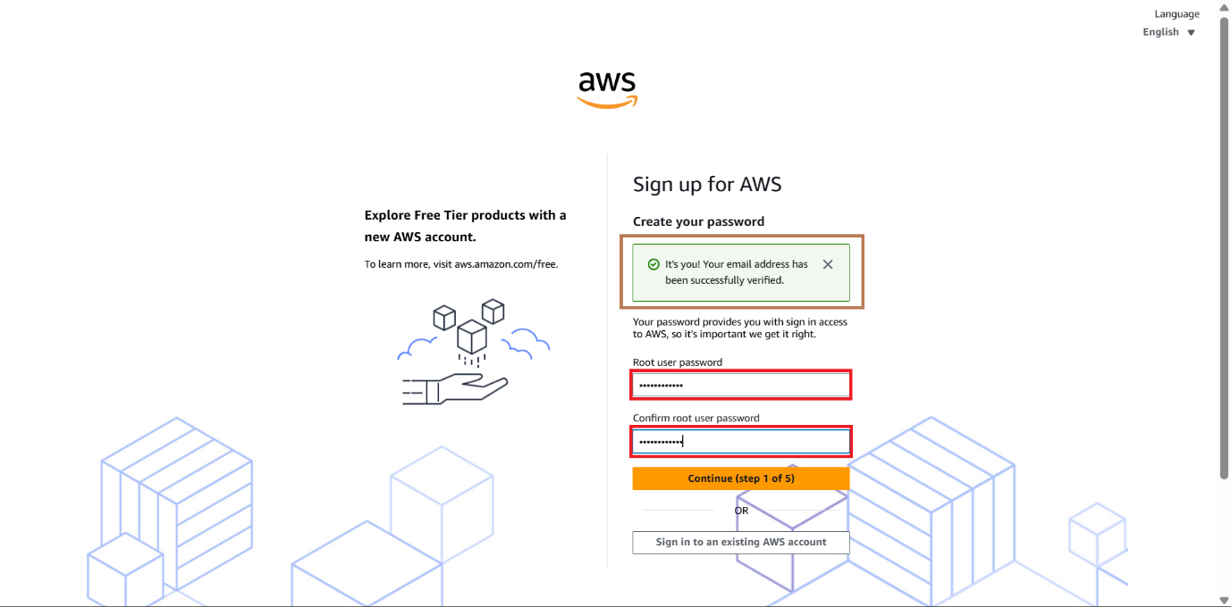

Step 7: Select Personal – for your own projects Radio Button and Enter Your all the Details then click Agree and Continue 🡪 **Step 2 completed out of 5**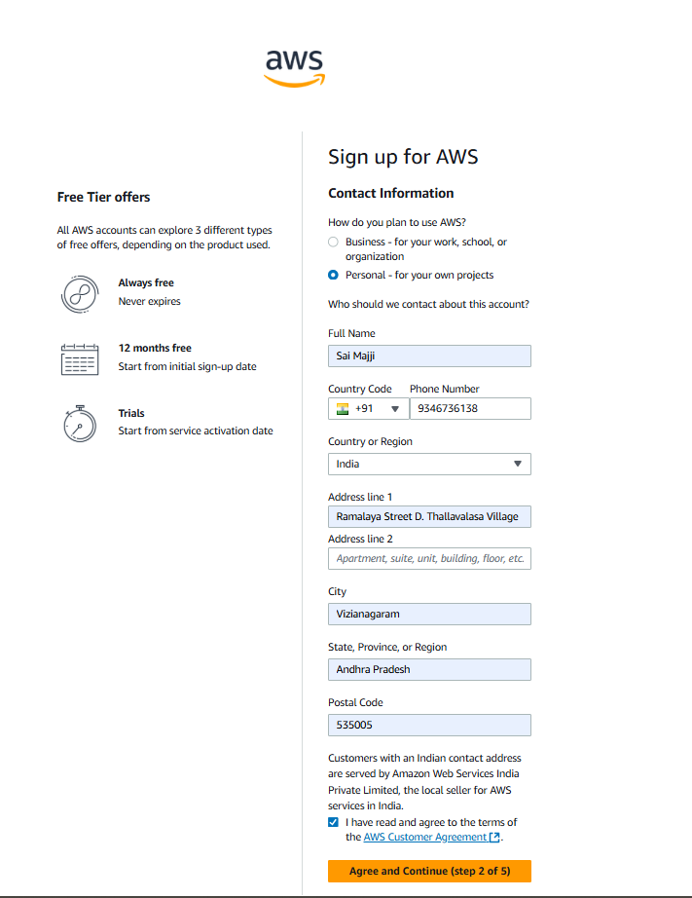



Step 8: Give Your Credit/Debit Card details here and Enter Your PAN Card Details then click on Agree and Continue 🡪 **step3 completed out of 5**

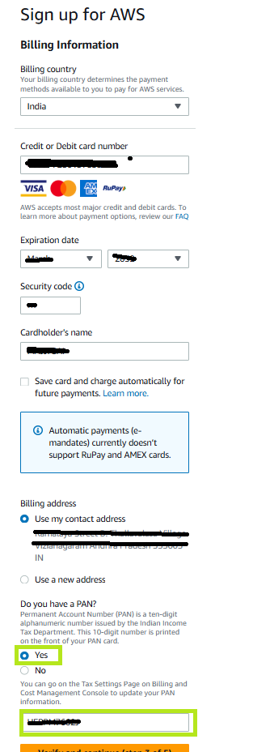

Step 9: You will receive a OTP Number to Your Registered Mobile Number. Enter the OTP in the Box and Click on Confirm. They will charge Rs 2 from Your Card

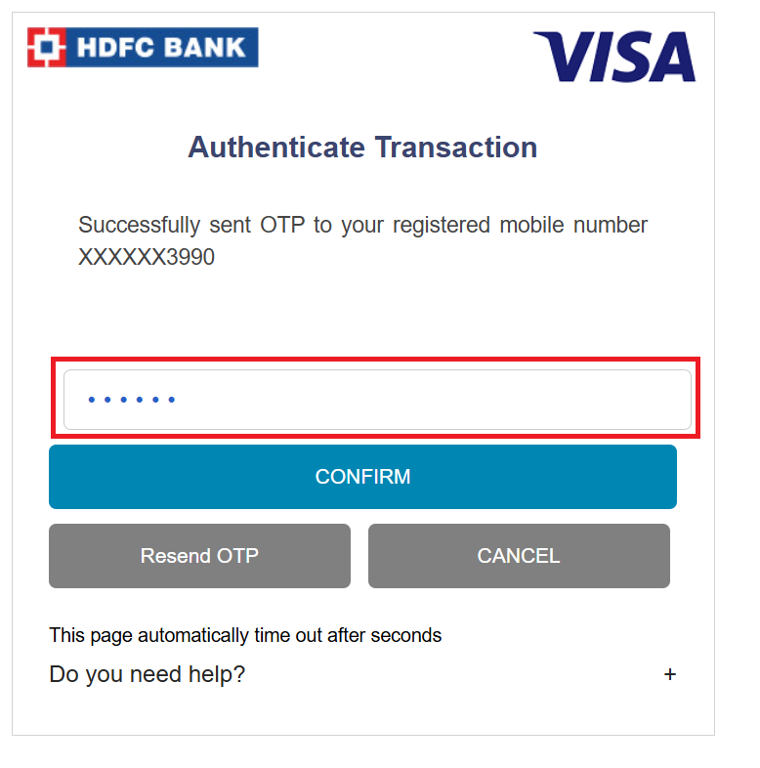

Step 10: Select PAN CARD and Give Your PAN CARD Details and Upload Your PAN CARD and enter your Mobile Number click on sent SMS then enter Capcha and Verification CODE 🡪 **Step 4 completed Out of 5**

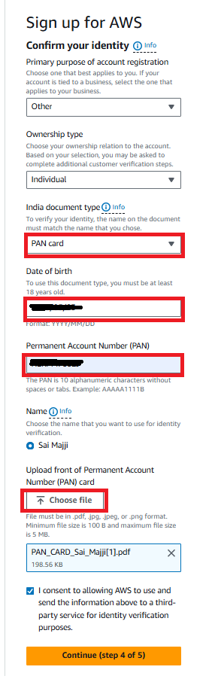

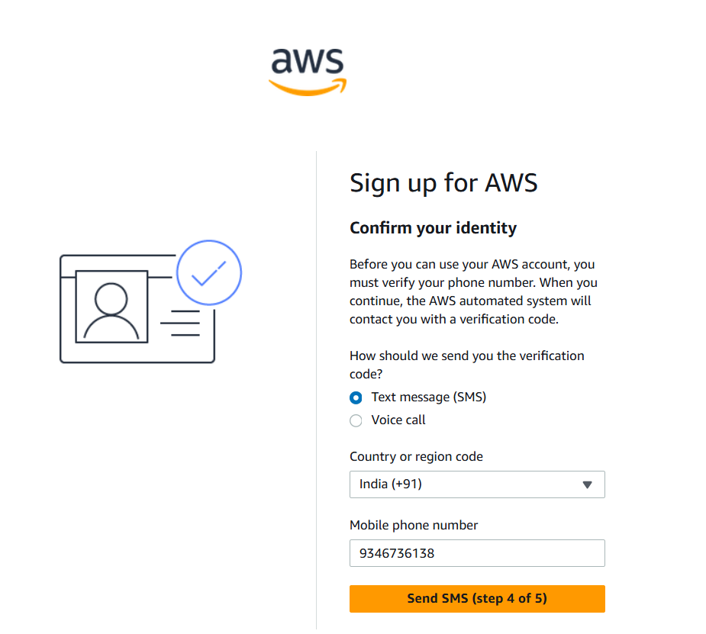

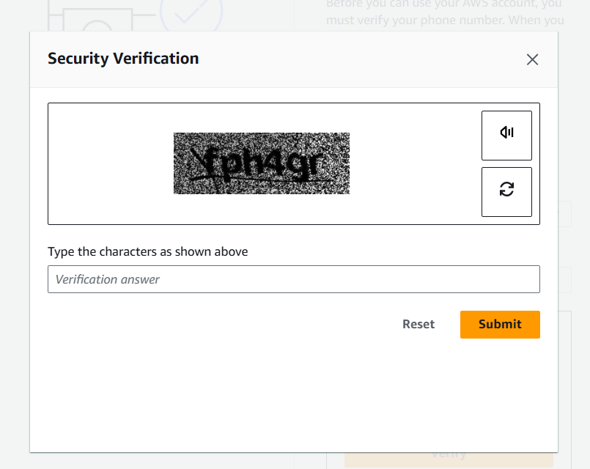

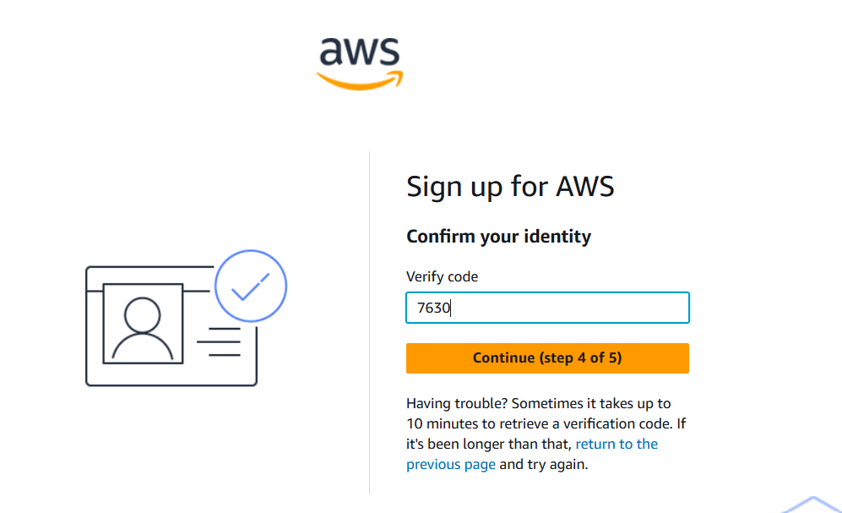

Step 11: Select Basic Support - Free Radio Button then Click Complete Sign up.

* With these steps AWS Account creation is Completed

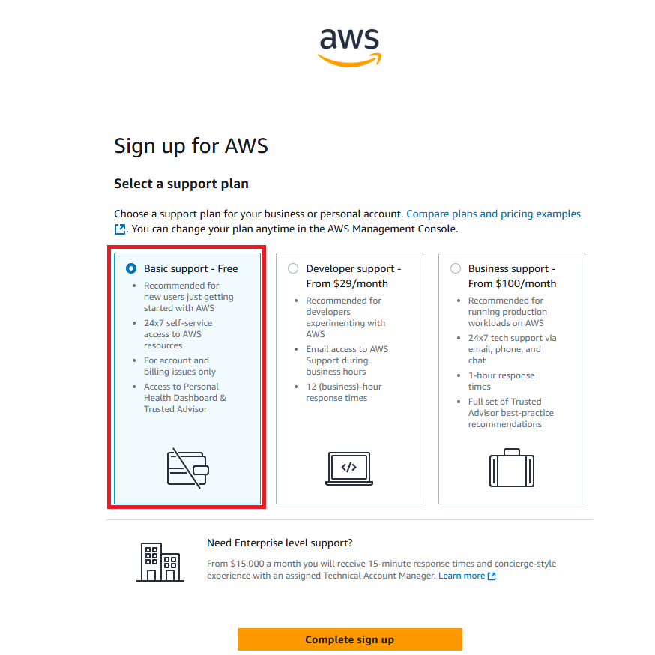

Step 12: Use this URL You Can Log in AWS Account with Your Credentials.

<https://aws.amazon.com/>

Step 13: Click on Sign in using root user email and Select root user and enter your Gmail and click on Next then Enter Your password then click on Sign in

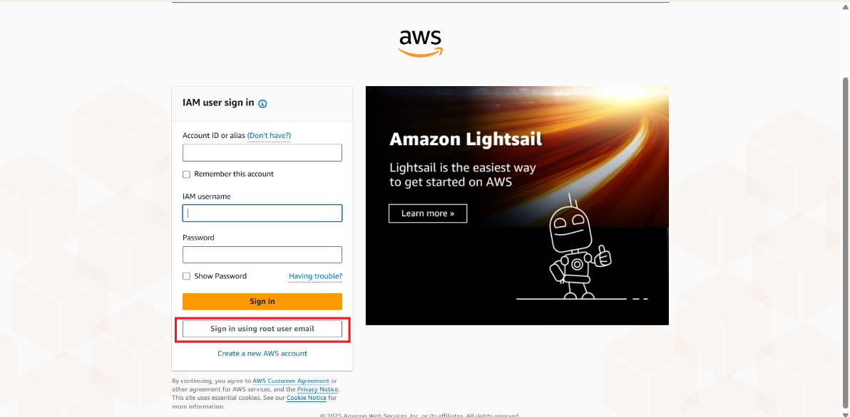

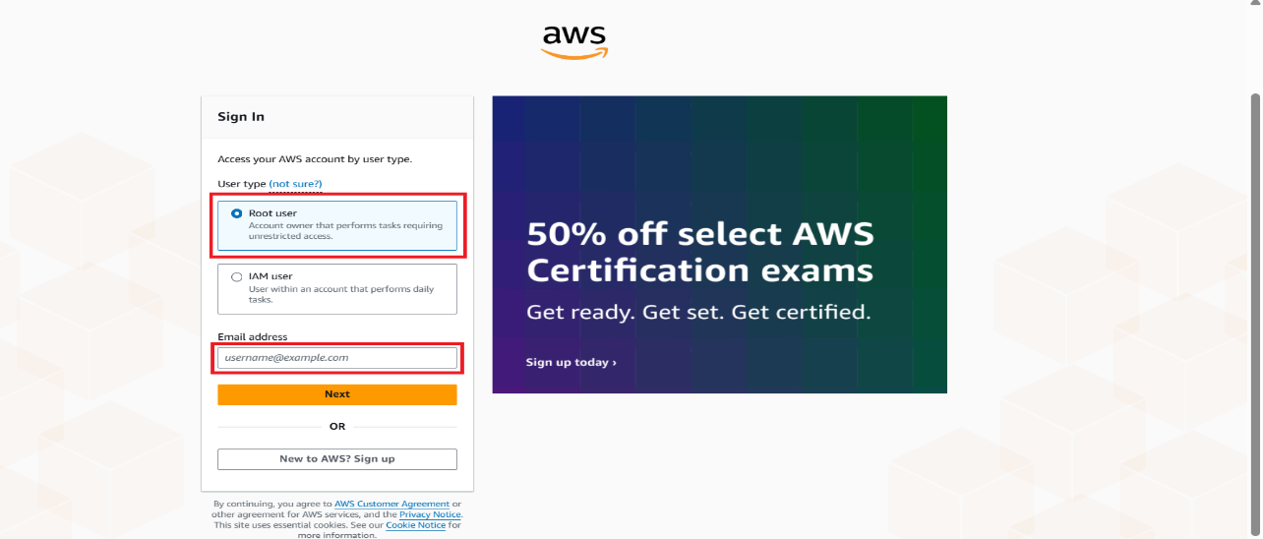

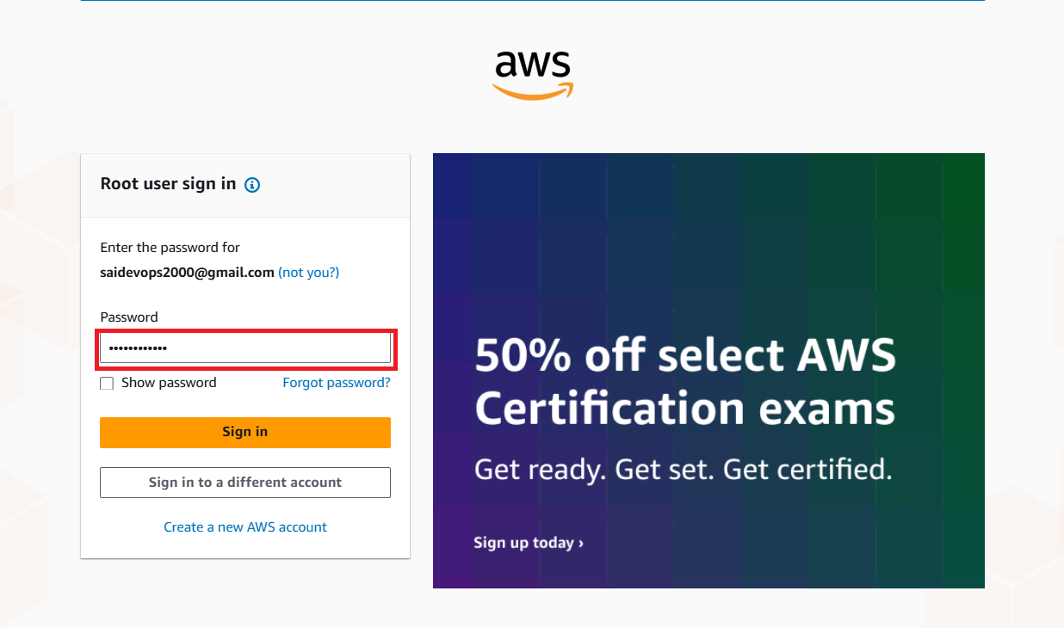

**Finally You will be landed on AWS Cloud Console**

